**Marklogic Server Setup Steps for IET TV**

1. Please install Marklogic server and run the service. We can verify running service from service list:

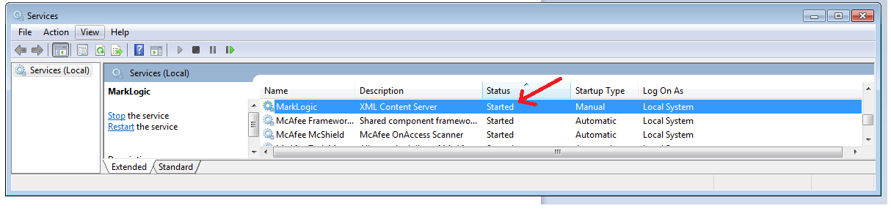

1. To Start Marklogic Query Console as follows. Open the Chrome Browser and type : **localhost:8000/qconsole**

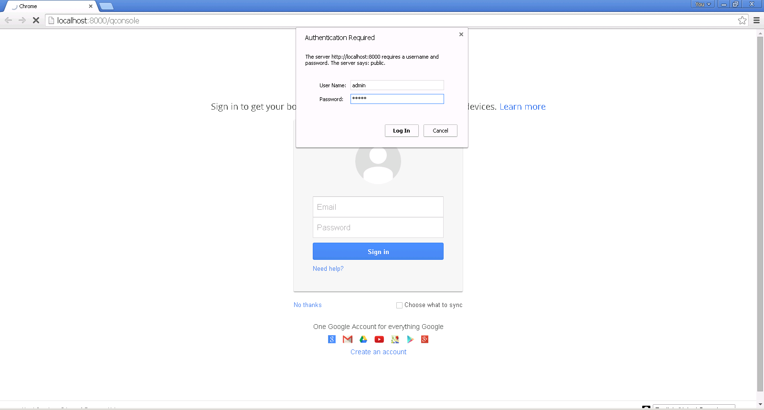

Enter the admin Username and the password of Marklogic Server and click on “**Log In**”.

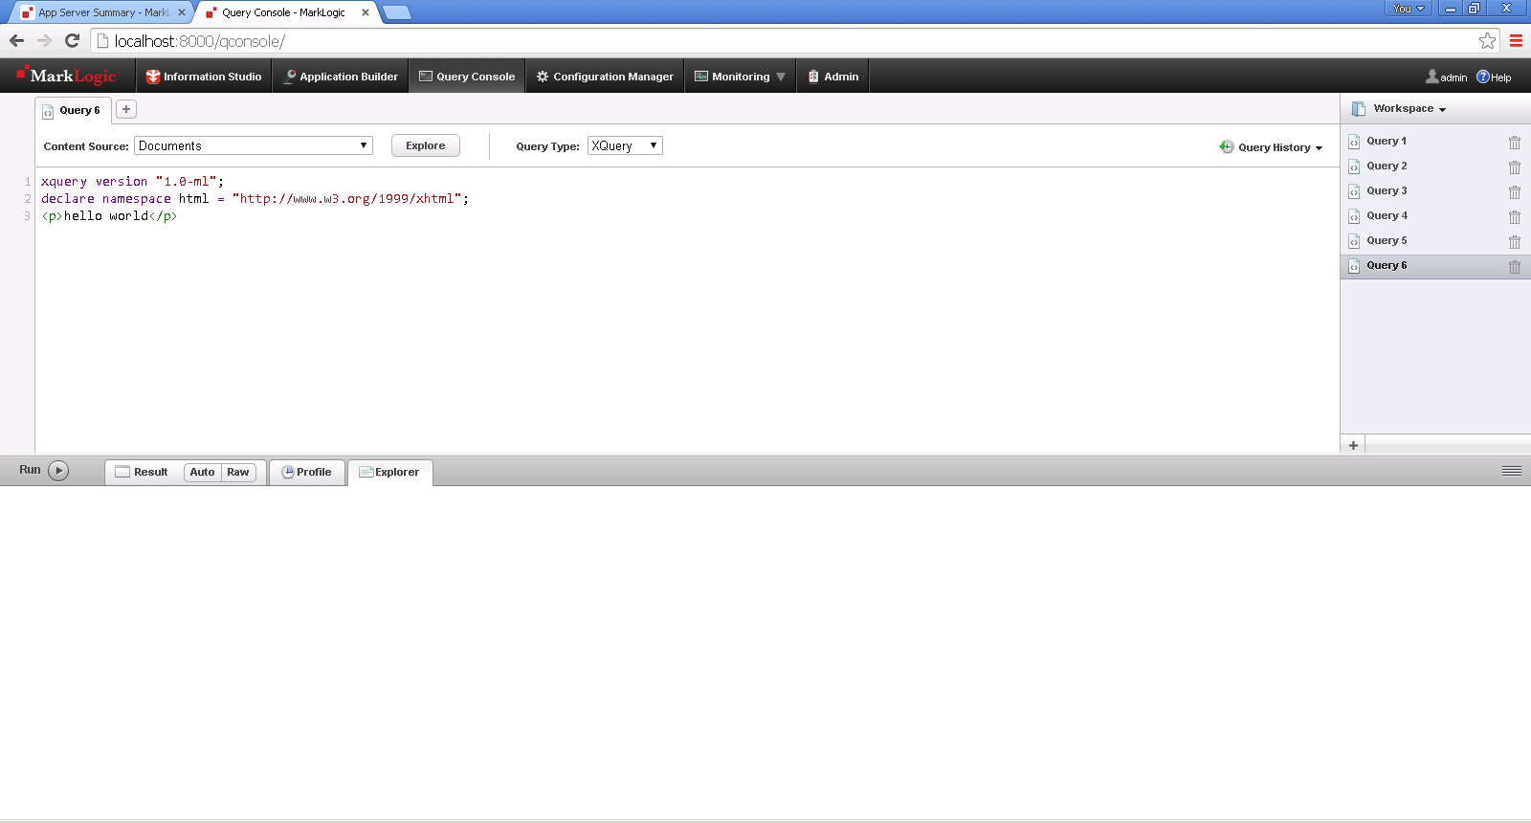

**Important : These scripts will create the Forests, Servers, Indexing and Schedulers in Marklogic.**

1. Unzip the file **IET_TV_MarkLogic_Code.zip** and extract to a local folder. We will see following folder

* XQuery
  + Application
  + Activity
  + Setup
  + RelatedContent

1. Open the File : **ApplicationSetup.xqy** from folder XQuery\Setup

Delete the existing code of Query Console Window. Now Copy paste the entire code of **ApplicationSetup.xqy**  file in the Query Console Window as shown below:

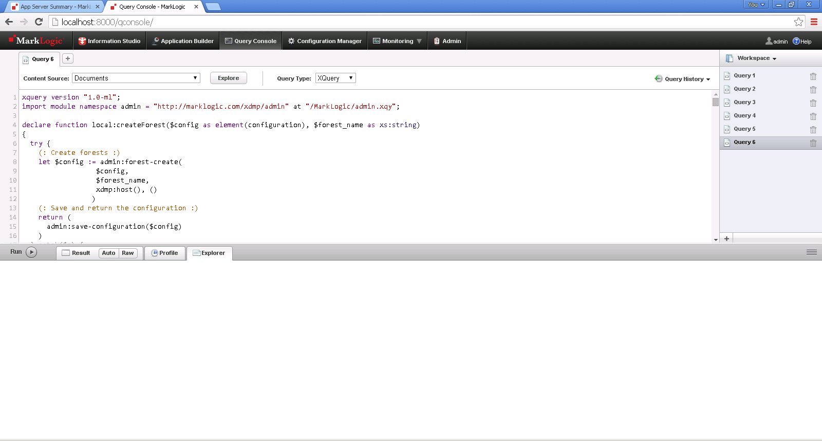

**Copy entire code here**

Click on the Run Button.

Above script will setup forest, database, index, XDBC server and WebDav Server, Scheduler.

1. Open the File : **ActivitySetup.xqy** from folder XQuery\Setup

Delete the existing code of Query Console Window. Now copy paste the entire code of **ActivitySetup.xqy** in the Query Console Window as shown below:



**Copy entire code here**

Click on the Run Button.

Above script will setup Activity Database.

1. Open the File : **RelatedContentSetup.xqy** from folder XQuery\Setup

Delete the existing code of Query Console Window. Now copy paste the entire code of **RelatedContentSetup.xqy** in the Query Console Window as shown below:



**Copy entire code here**

Click on the Run Button.

Above script will setup RelatedContent Database.

**IETTV Latest Deployment:**

**Steps to deploy XQuery Code on IETTV-Database**

* Open WebDAV folder - **\\localhost@** **PortNumber \DavWWWRoot**(please specify port pointing to activity database)
* Copy all files from folder Application and paste on folder - **\\localhost@** **PortNumber \DavWWWRoot**including sub-folder

**Steps to deploy XQuery Code on IETTV-Activity Database**

* Open WebDAV folder - **\\localhost@PortNumber\DavWWWRoot** **(**please specify port pointing to activity database)
* Copy all files from folder Activity and paste on folder - **\\localhost@PortNumber\DavWWWRoot**including sub-folder

**IETTV Default Carousel Set:**

**To Set Home Carousel**

* Open **DefaultHomeCarousel.xqy** file and copy paste on Query Console and Run

**To Set All Channel Carousel**

* Open **DefaultChannelCarousel.xqy** file and copy paste on Query Console and Run